Contents

001 2

M11_Escape_Velocity 3

M13_Observatory 4

M10_Food_Production 5

M12_Satellite_Orbits 6

ReturnToBase_M12_M00 7

Escape_Velocity_2 8

Observatory_2 9

Return_to_Base_M10_M00 10

Food_Production_2 11

M02_Solar_Panel_Array 12

M01_SpaceTravel 13

M05_Extraction 14

M03_3DPrinting 16

Other SPA (other team's Solar Panel Array) 18

MENU 20

## 001

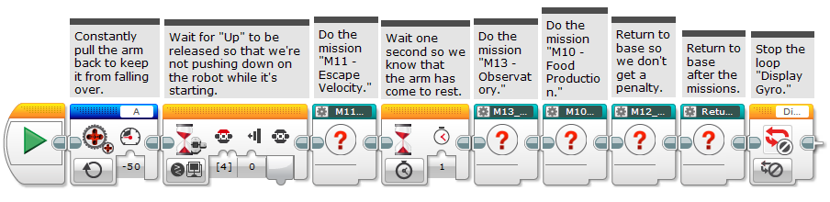

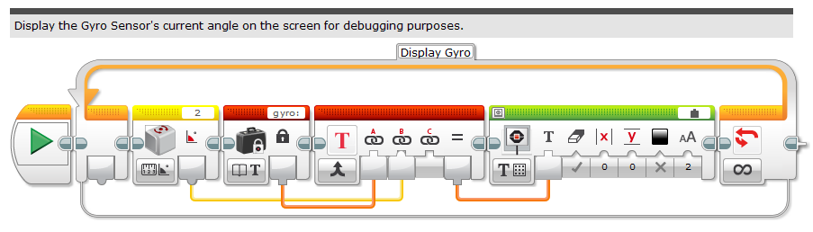

## M11_Escape_Velocity

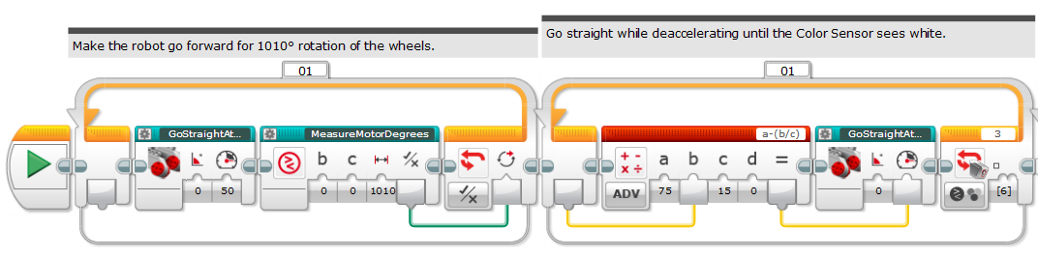

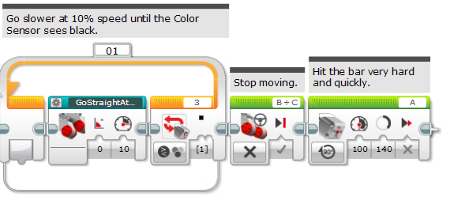

## M13_Observatory

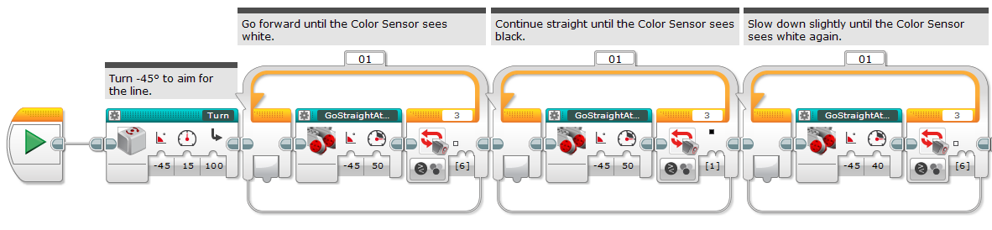

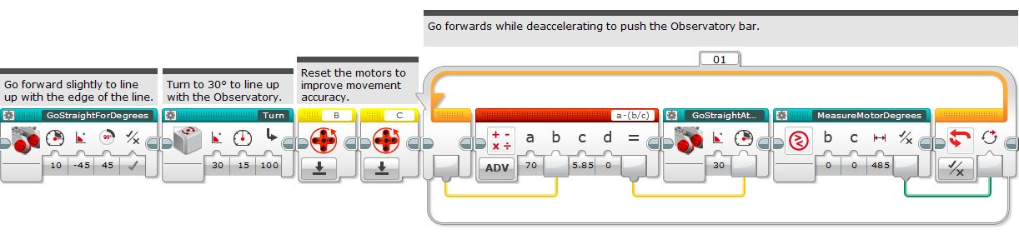

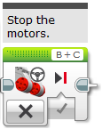

## M10_Food_Production

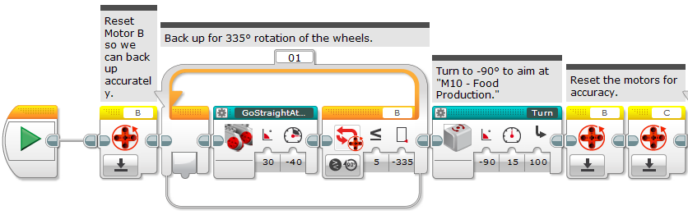

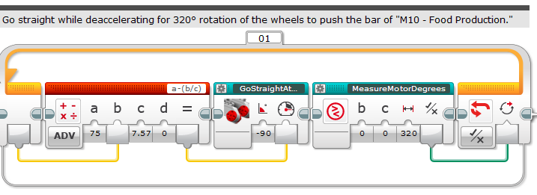

## M12_Satellite_Orbits

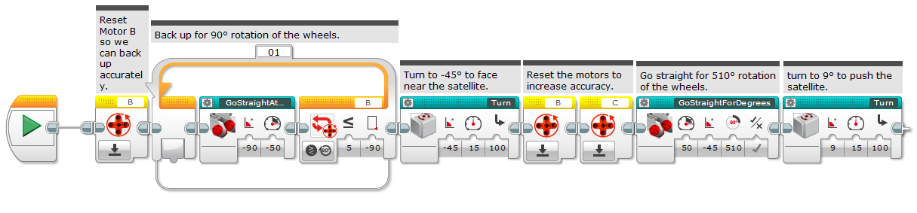

## ReturnToBase_M12_M00

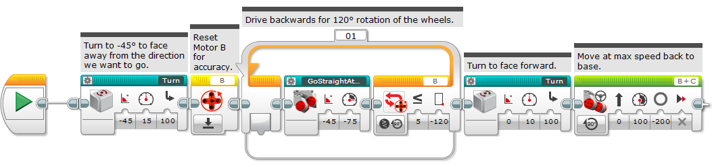

## Escape_Velocity_2

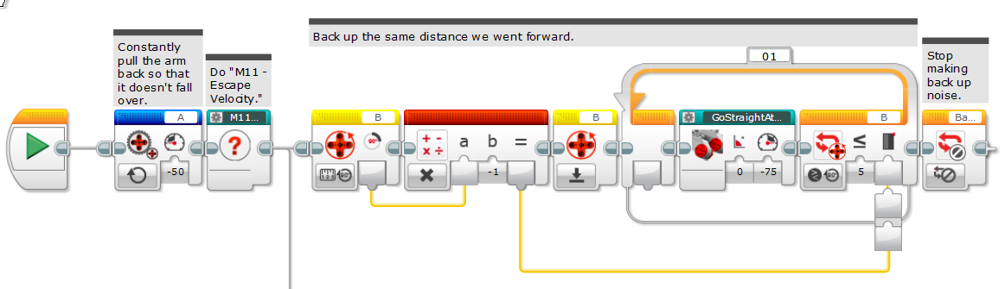 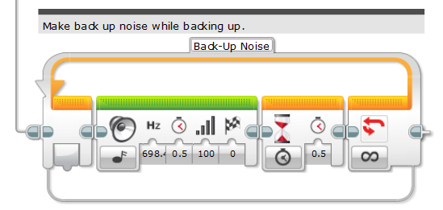

## Observatory_2

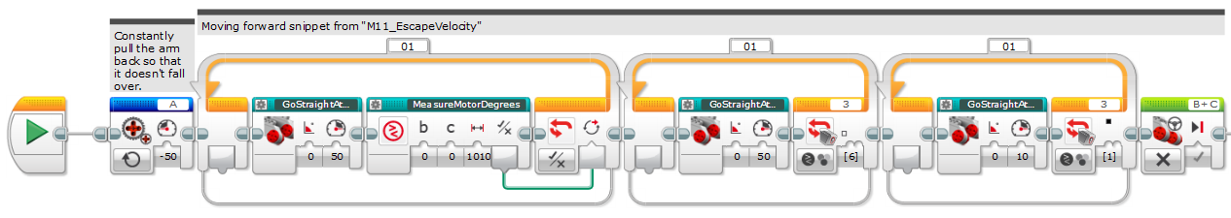

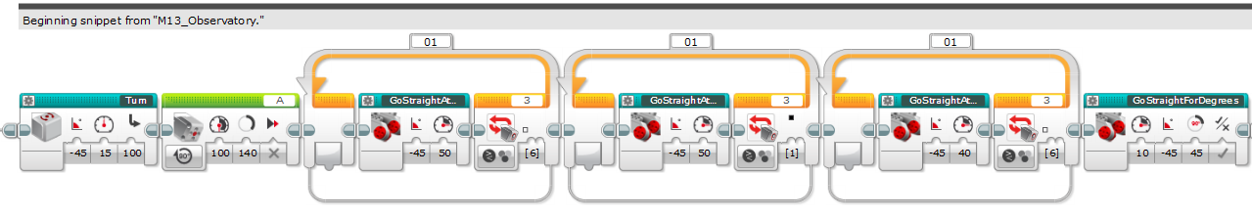

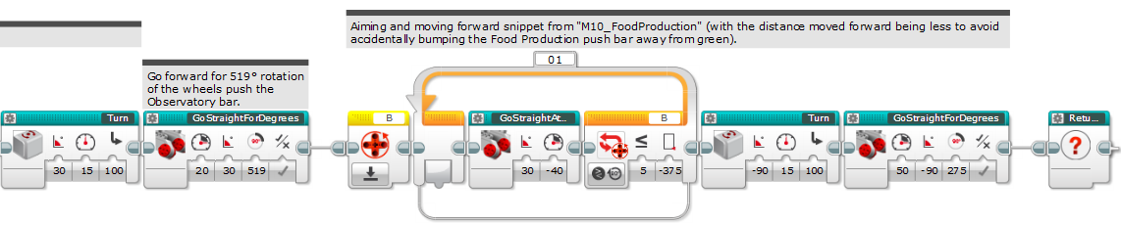

## Return_to_Base_M10_M00

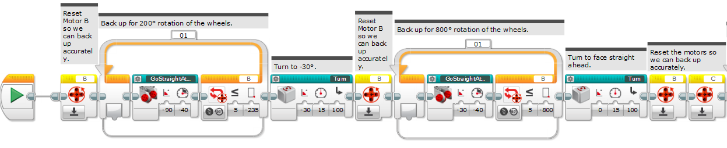

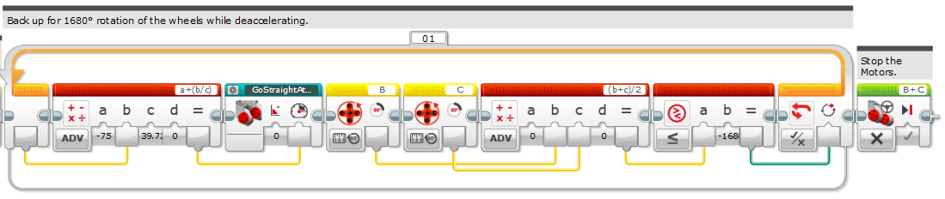

## Food_Production_2

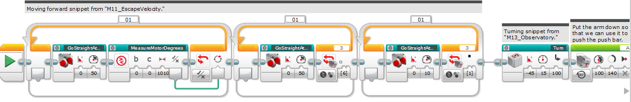

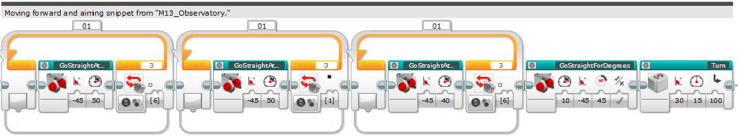

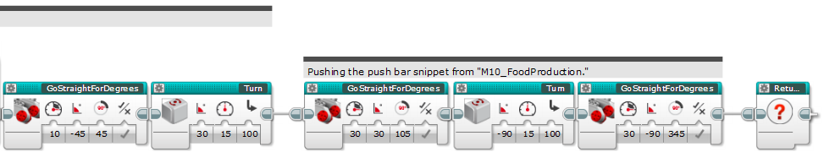

## M02_Solar_Panel_Array

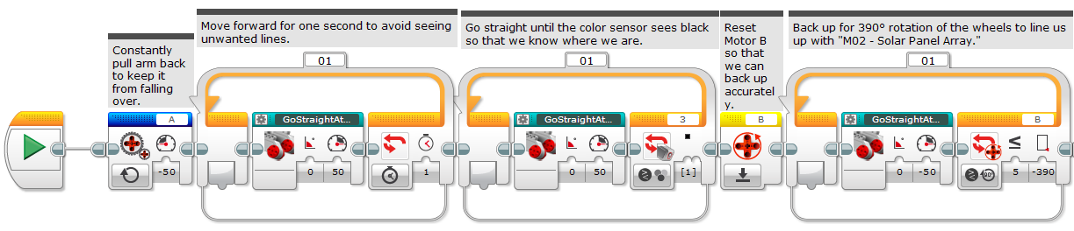

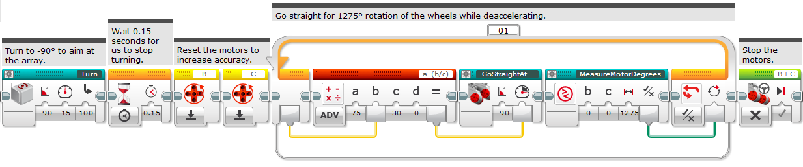

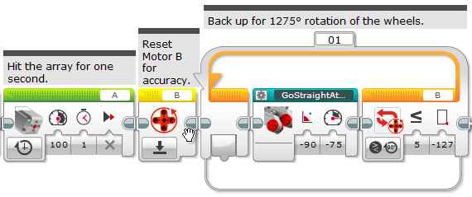

## M01_SpaceTravel

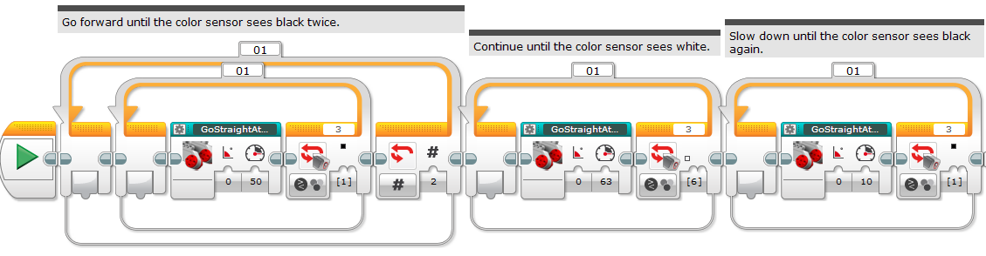

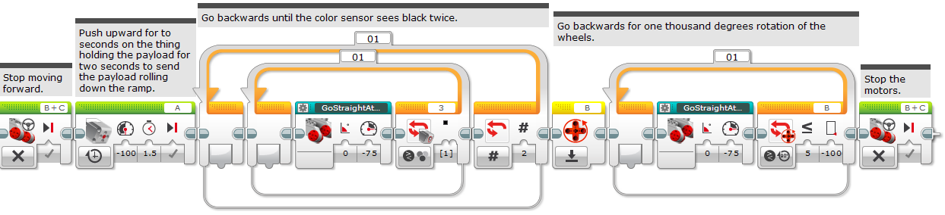

## M05_Extraction

(page 1 of 2)

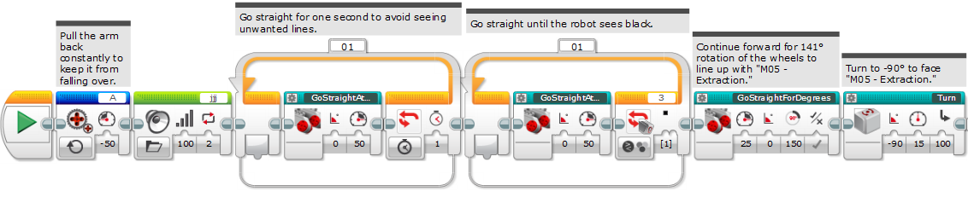

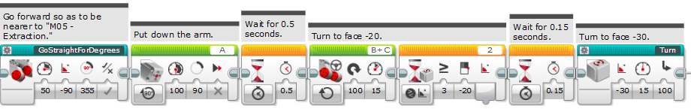

(continued on next page)

M05_Extraction (page 2 of 2)

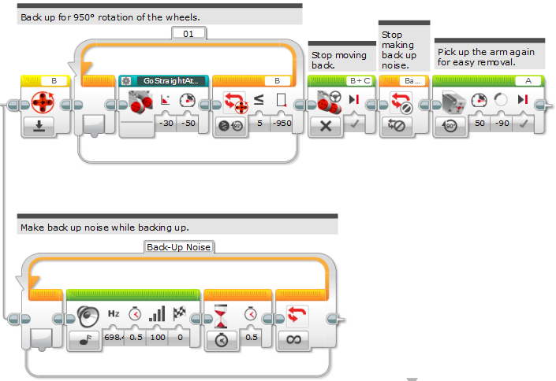

## M03_3DPrinting

(page 1 of 2)

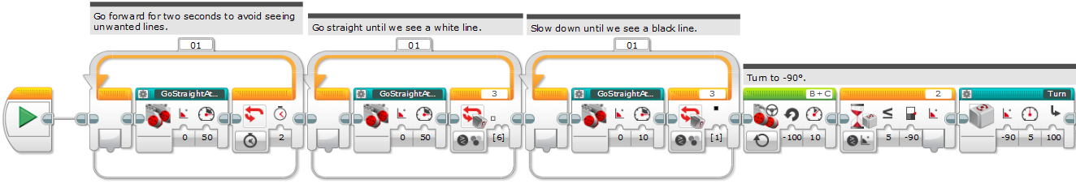

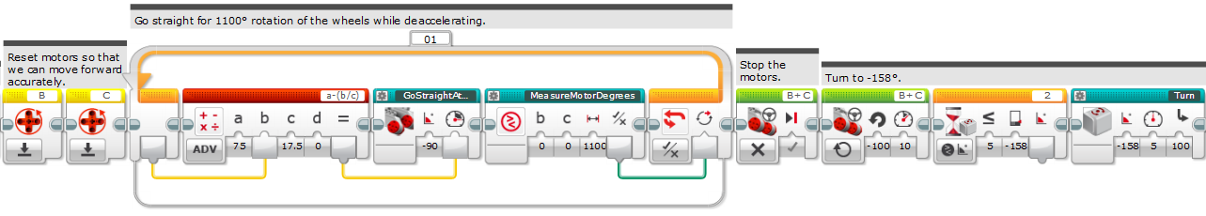

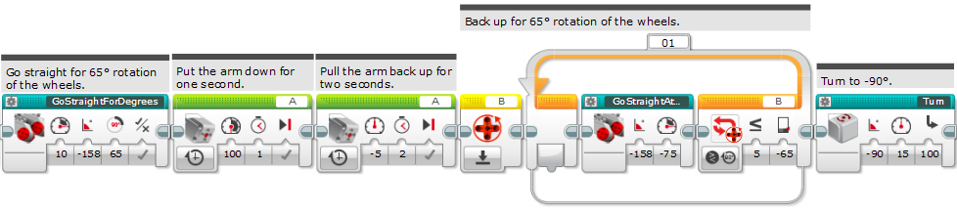

(continued on next page)

M03_3DPrinting (page 2 of 2)

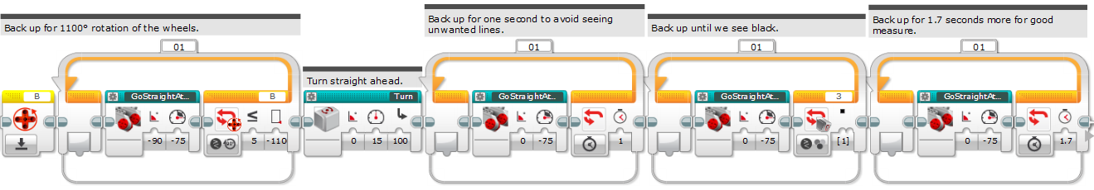

## Other SPA (other team's Solar Panel Array)

(page 1 of 2)

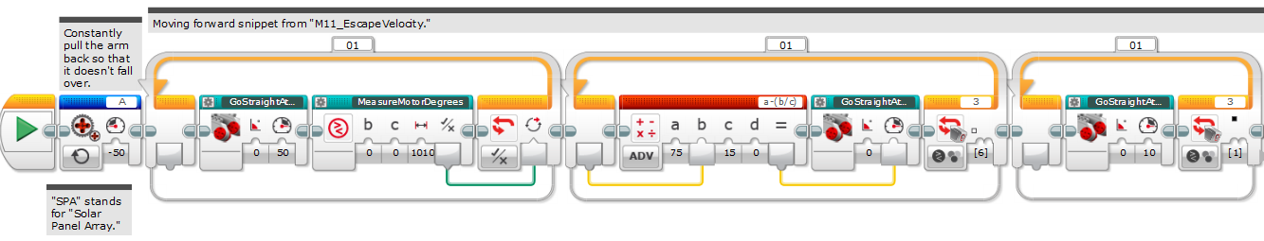

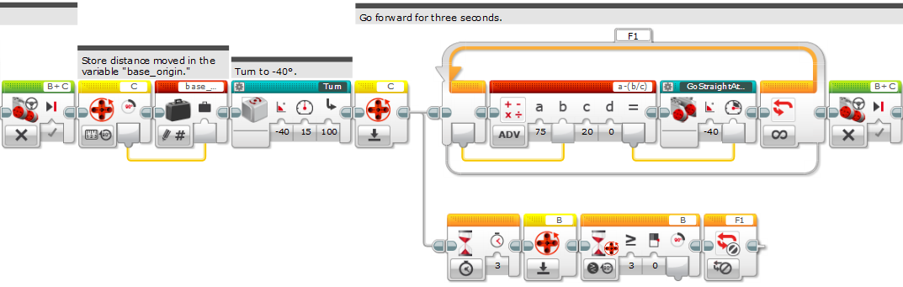

(continued on next page)

Other SPA (page 2 of 2)

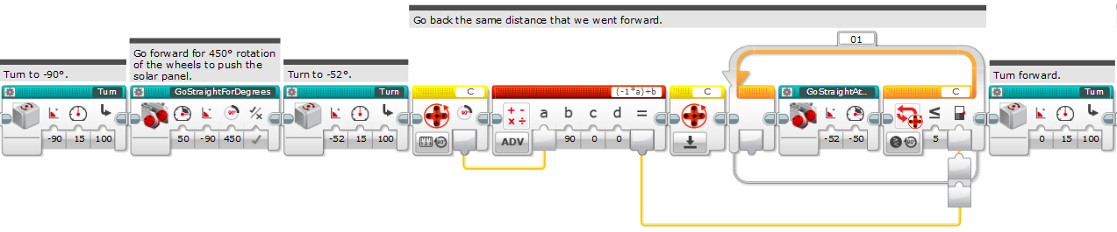

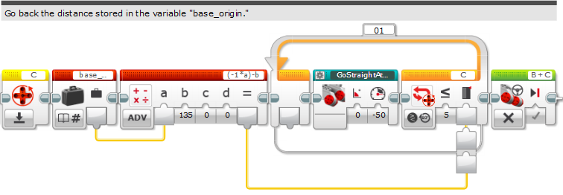

## MENU

(page 1 of 2)

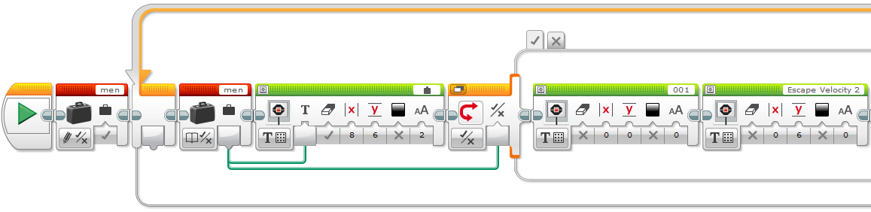

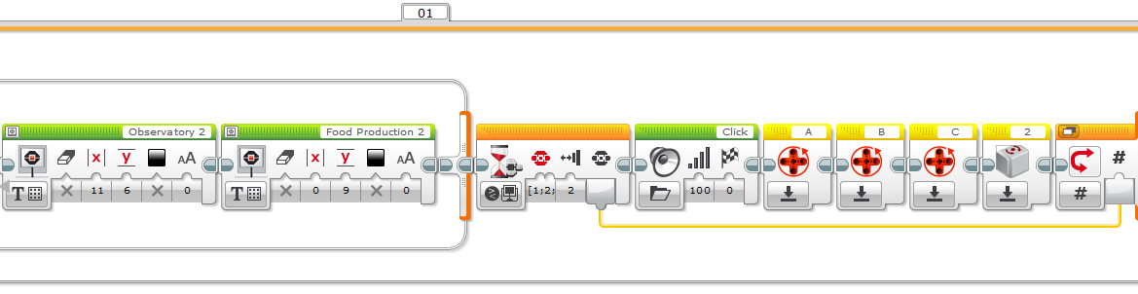

(continued on next page)

MENU (page 2 of 2)

